

**Test 1 Vectors, Projectile, Circular, Gravitational & Satellite motion  
PHYSICS 3AB TASK 3**

**Kingsway Christian College**

**March 6, 2015**

Instructions:   
Answer **ALL** questions.  
You may use your formula book and scientific calculator.  
Give all numerical answers correct to 3 significant figures.  
You are required to show **ALL** working in order to be given appropriate marks.   
A correct answer with no working could receive only ${\frac{1}{5}}^{th}$ of the marks allotted.   
It is a good idea to draw free body diagrams for questions involving forces.

It is also good to use clear, neat diagrams when appropriate.

**Marks________/85 = _______%**

**Section A: Short answer questions 35 out of 85 marks.**

1. A person $P$ walks at a speed of 1.50 m.s−1 on a moving travellator $T$ in an airport terminal. The travellator moves at 0.800 m.s−1. How fast is the person moving with respect to the Earth $E$? [2]
2. A river flows due east at 5.00 km.h−1. A motorboat can move through water at 12.0 km.h−1.
   1. If the boat heads due north across the river, what will be the direction and magnitude of its velocity. [2]
   2. In what direction should the boat head if it is to travel due north across the river? [2]
   3. If the river is 250 m wide, how long will the crossing described in part b) take? [2]
3. A pilot of a Qantas jet flies from Perth to Sydney. Assume Sydney is due east of Perth. During the flight there was a constant 120 km.h−1 blowing from the northeast. The jet had an airspeed of 1000 km.h−1. The fight time was 4.50 hours. What is the displacement of Sydney from Perth? [3]
4. Below are two sketches of paths of an object in projectile motion. One motion is without air resistance and the other is with air resistance. The initial projectile velocity is shown as $\vec{u}$
   1. Indicate which the one with air resistance is. [1]
   2. At the positions marked A, B & F draw arrows to indicate the appropriate vectors showing, the vertical, horizontal and resultant velocities. [3]
   3. 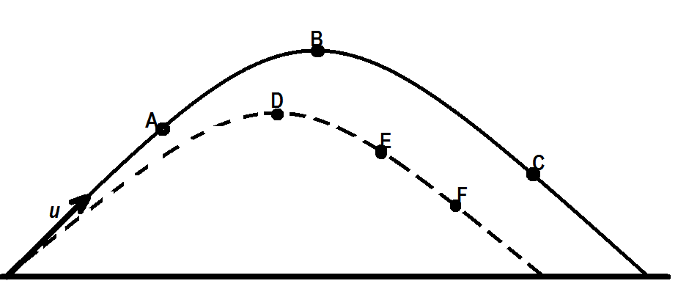 At the positions marked C, D & E draw arrows to indicate the appropriate vectors showing the resultant acceleration. [3]
5. Suppose a car moves at constant speed along a hilly road. By choosing from the following four alternatives and explaining with diagrams and equations:  
     
   (a) at the top of the hill,   
   (b) on a horizontal level stretch near the top of a hill,  
   (c) on a horizontal level stretch near the bottom of a hill,  
   (d) at the dip between two hills,  
     
   Where does the car exert:  
   1. the greatest force on the road: [2]
   2. the least force on the road: [2]
   3. the same force on the road [2]
6. How many “accelerators” do you have in a car? There are at least three controls in the car which can be used to cause the car to accelerate. What are they? What acceleration do they produce? [6]
7. Between the Earth and the Moon:  
   1. Which pulls harder gravitationally, the Earth on the Moon or the Moon on the Earth? Explain briefly. [1]
   2. Which accelerates more? Explain briefly. [1]
   3. If the Earth’s mass were double what it is, in what ways would the Moon’s orbit be different? Briefly explain? [3]

**Section B: Calculations 50 out of 85 marks**

1. 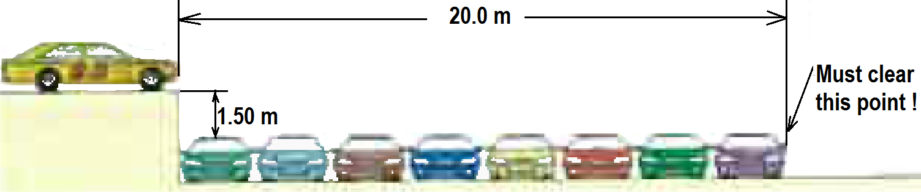 A stunt driver wants to make his car jump over eight cars parked side by side below a horizontal ramp.   
   1. With what minimum speed must he drive off the horizontal ramp? The vertical height of the ramp is 1.50 m above the cars, and the horizontal distance he must clear is 20.0 m. [4]
   2. If the ramp is now tilted upward, so that “take-off angle” is 10.0o above the vertical, what is the new minimum speed? [5]
2. A 0.450 kg ball attached to the end of a horizontal cord, is rotated in a circle of radius 1.30 m on a frictionless horizontal surface. If the cord will break when the tension in it exceeds 75.0 N, what is the maximum speed the ball call have in m.s−1 and also in rotations per minute (rpm) [4]

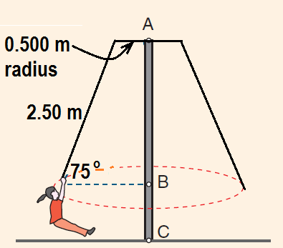A 40.0 kg girl is playing on a maypole swing in a playground. The 2.50 m long rope is attached to a 0.500 m radius horizontal bar at the top, and makes an angle of 75.0o to the horizontal as she swings freely in a circular path. Ignore the mass of the rope in your calculations.

* 1. Calculate the radius of her circular path. [1]
  2. Indicate on the diagram, the forces acting on the girl as she swings. [2]
  3. What is the net force and net acceleration on the girl in the position shown? [3]
  4. Calculate the rotational speed and tension in the rope. [5]

1. 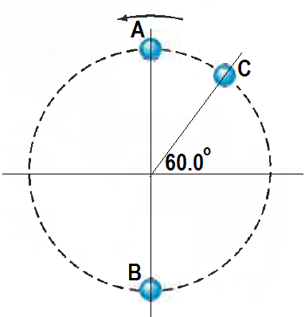 A ball on the end of a string is revolved at a uniform rate in a vertical circle of radius 72.0 cm as shown. If its speed is 4.00 m.s−1 and its mass is 0.300 kg, calculate the tension in the string when the ball is   
   1. At the top of its path $A$. [3]
   2. At the bottom of its path $B$. [3]
   3. At 60.0o from the horizontal upwards as it moves upwards $C$. [3]
2. Calculate the acceleration due to gravity on the surface of the moon. [3]  
     
     
     
     
     
     
     
     
     
     
     
   1. During an Apollo lunar landing mission, the command module continued to orbit the Moon at an altitude of 100 km. What is the gravitational field strength at this altitude? [2]
   2. How long did it take to orbit the Moon at this altitude? [3]
3. 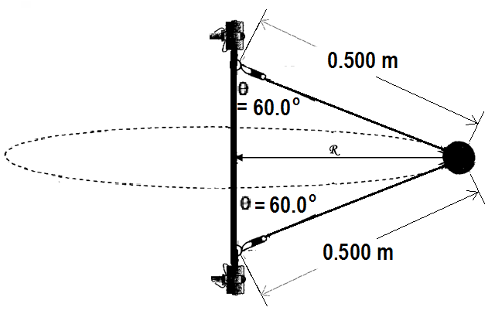 A toy device is made up of a 200 g ball attached by two cables to a spinning shaft as shown. Calculate the tension in each cable when the shaft spins at 360 rpm. [5]
4. A boy throws a dart at a certain angle upwards from the horizontal, 2.00 m from the dartboard. The dart hit the dartboard at the same height above ground that it was thrown. It was observed that it achieved a maximum height of 19.6 cm above the release point. Calculate the angle and the release velocity of the dart. [4]

**END OF TASK 3 (Test 1)**